Marlene Gretta (Meendering) Stubbe
Published by Dylan Kruger
Written in the Year 2014
Marlene Gretta Meendering born on January 29, 1940 at 4:00 a.m. She was in a farm house near Doon, Iowa. She was welcomed home by her parents, Andrew Frank Meendering, a farmer, and Ella Van Mannen, a housewife. Her eye color was blue and her hair color was blonde.
Marlene was the first born in her family. She has two brothers and five sisters. Gerald Edwin, the second oldest, was born on November 18th, 1942. Her other brother, Edward Gerrit was born on January 6th, 1945. Her sister, the fourth oldest, Gladys Mae, was born on March 5th, 1949. Her other sister, Luella Ann, was born on January 24, 1952 (deceased). Audrey Elaine was born on May 2, 1953. Lucille Arlene was born on November 9, 1954. Eleanor Joyce was born August 18th, 1956.
Back Row (left-right): Marlene, Gerald, Edwin, Gladys, Audrey
Front Row (left-right): Lucille, Ella, Eleanor
Marlene at age 3
As a child, Marlene enjoyed going on one day fishing trips with her neighbors. Going to her uncles and aunts and grandpa and grandmas on a Friday or Sunday night/afternoon was a favorite time for her. In the summer, she enjoyed watching ball games.
One interesting thing that Marlene did when she was a kid was sneak to her Grandma’s house. She did this most often when she was four and five. Her Grandma Van Maanen’s house was about 1,000 feet away, so she could walk over there. When she got there, her grandma always asked for a note from her mom that said she could be there. Otherwise she was sent back home.
Fishing trips
During the warm summer when she could play games, Marlene would play five hundred, but in the winter she would play Fox and Goose. Hide and Seek and also swinging on the sack swing were a favorite activity of hers. She enjoyed playing these games with her friends Arlene DeBeer, a classmate with her at the country school, and also Melvina (Nagel) Klaassen, who was a neighbor.
(Left-right): Marlene, Kathryn, Arlene
Toys that Marlene played with were different than the ones we have today. They made paper dolls by cutting families of them out of old catalogs. They would make a playhouse for them in the corn crib. Another place that they would make playhouses was in the grove. These houses were usually made out of tree branches. One thing that they did the most often though was riding bike and riding on the sack swing.
When Marlene wasn’t playing games with her friends, she had to do chores. Her chores included: gathering eggs, picking up cobs for the stove, and sometimes milking cows by hand. The chore she did the most, however, was making meals for the family and washing the dishes by hand because she did not have a dishwasher. In the summer, she had to walk the bean and corn fields and pull out all the weeds.
One thing Marlene remembers about her family was that everyone had to do their share of the work. In the summer, they had designated times to ride bikes or play outside. The times were from 1:00-3:00 p.m. Marlene’s dad was also the boss of the family, and you did not talk back to him. The house had no basement, and it was already a small house, so they usually played outside. Marlene spent her time watching her younger brothers and sisters. One thing that the family always did together was eat. They would sit at the table for breakfast, dinner, and supper.
Ella and Andrew Meendering
One time when her dad really showed them who was boss occurred in the middle of summer. Marlene was only eleven at the time, and her aunt was thirteen. They decided that it was too hot outside and were going to go get shorts on. Her dad did not approve. When they came back out with shorts on, her dad immediately sent them back in. He told them that if they didn’t get different clothes on right now, they had to run out to their neighbor who was in the field and bring him his lunch. But that was not the only thing they had to do; they had to do it naked. They both quickly ran back inside and put different clothes on. That was the last time they tried to wear shorts with Marlene’s dad around.
Marlene and her aunt
One of Marlene’s favorite parades included the Corn Show, which she went to often. She would also visit the Turkey Days Parade in Worthington, but this did not happen often.
The weekends were when Marlene could have fun, but Monday through Friday, she had to go to school. One interesting memory that Marlene has about her country school happened when she was in elementary school. It was either fourth or fifth grade, she couldn’t remember. They were trapped inside the school house because the door knob broke off. The smallest kid in the school that would know what to do when they got out was Marlene. They all looked at her, and she knew that she was the one that had to be pushed out the coal chute door. Only, it didn’t go exactly as planned. When they pushed her up to get her through, she was not ready and didn’t have her head down. She smacked her head against the top of the door, leaving a deep gash on the top of her head. That’s all she remembered for a while. She does not know how they got out of the school house or even hitting her head. The next thing that she remembered was being on a table at the doctor’s office getting stitches (approximately 10) and her clothes were doused in blood.
Marlene’s class at school
The 4th of July was a fun event that they got to go to in the summer. They usually went to Rock Rapids with some family friends. Their day included a picnic and shooting their own fireworks. In the summer, they also had a big Van Mannen family reunion in Sioux Falls, South Dakota. They usually got together at McKennan Park. On the other hand, in the winter the family would gather with the Meenderings. This went on until Marlene’s father died.
One event that wasn’t as happy as the 4th of July also took place on the 5th of July, 1953. Marlene’s family experienced a twister with wind and hail. It destroyed their crops and took down lots of trees. They didn’t have a basement, so all they could do was stand there and watch it. In this same week when their whole farm had been wiped out, Marlene’s younger sister Luella died almost one week later on July 11th, 1953 from a farming accident. Marlene had to run out into the field to get her dad, who was getting the field ready for planting again, but by that time it was too late.
Fallen trees after the twister
Marlene has moved many different times in her life. Marlene lived by Doon, Iowa until she was seven years old. She then moved near Ellsworth, Minnesota where she lived until she was married. The house she lived in was relatively small. It had three rooms and a porch on the main floor. The upstairs, on the other hand, only had two rooms, with the steps ascending into one of them. Her basement was a little different. A cellar that was only accessible from the outside and a gravel floor was not visited often by her. What heated their house was an oil burner in the living room, and a cob and wood stove in the kitchen. Bathrooms were not a luxury they had at the time. For the first three or four years that they lived in Ellsworth, there wasn’t even running water or electricity. The water had to be carried in for drinking, for washing, for dishes, and for clothes. All this water also had to be carried out after it was used. All their neighbors were in this same situation. One thing different about her house was that they had one phone, and it was on the wall. This phone was a party line where there were eight to ten households on it, so if you called someone, it was usually short because everyone could listen in on your conversation.
Marlene’s house near Ellsworth
To get other supplies for the house they had to go only on Saturday night, unlike today when people will go to town any day to get food or something else any day of the week. Her mother would shop for as long as an hour or hour and a half for supplies that would last the whole week. In the summer and spring when her mom would shop, her cousin and she would have to push their sisters in a buggy so they would be content.
Marlene with the buggy
Vacations did not happen very often. However, when Marlene was seventeen years old, she went on a trip to California. There was one thing they had to do before they left, and that was to buy swimming suits. They went to the pool for the first time in California and swam for the first time ever in their lives. So when they went swimming, all they could do was go in the shallow end.
Every summer, they did a tedious job. They had to butcher and clean seventy-five to one hundred chickens. There was a specific way they had to do this. They had an assembly line. The first one had to catch the rooster, which was in a chicken crate, and they tied them with twine strung by the legs on the clothes line. The second one would cut the head off while the third one cleaned it. The fourth one took the insides out. Marlene was usually the one that had to do the skinning or the gutting because she was the oldest. Her mother would cut the legs off and put them in tank of ice water to cool before they put them in the freezer. By that time, they had electricity, so they had a freezer. The last one took the legs out of the twine and brought it back to the front of the line.
Marlene in California

Marlene’s favorite food during her childhood included liver and onions. She also enjoyed fish and sweet potatoes. On the other hand, her least favorite food of all time was boiled potatoes or mashed potatoes. She didn’t like these foods because her father would make her sit there at the table until she ate them, even if it was until midnight.
Marlene started school in Sioux County at five years of age in the first grade. She started there because there wasn’t kindergarten in Doon. When she was seven years old she left that school and went to Midland #6 in Lyon County. There were nine grades in that school (K-8). All these grades were in one small school house with one teacher. She attended high school in Little Rock, Iowa.
Marlene’s classroom
Marlene’s favorite subjects included Math and History. Her favorite teacher was Pearl Popkes. She enjoyed Miss Popkes because she would come outside with them for recess and play. She also liked the fact that Pearl was a teacher who helped put on many nice plays for the Christmas program.
Marlene lived half of a mile from the school, and they had to walk there and back every day. It wasn’t until high school they were able to ride the bus.
Marlene was given a choice from her father about school. She could either be in sports or music. She could not do both. Marlene made the choice to do music. She was in band, girl’s glee club, and mixed chorus. This means that there were boys and girls in it. She also did plays in school.
Marlene (holding the tambourine in the air) at a Christmas play
At the end of the school year, they had to take a final exam in History class. As the dreaded test was being handed out, the teacher stopped at Marlene’s and another girl’s desk next to her. He said, “Because you already have an A in this class, you do not need to take the test and may leave and do whatever you want.” So they did what every normal kid would do, and they walked downtown to the grocery store and got a candy bar. They went back to the school to watch everybody else take the test.
Marlene’s least favorite memory of school was when they had to sew a blouse in Home Economics class. On the other hand, her favorite memory was being the Valedictorian, although she was a little nervous that she had to make the speech at graduation. Another thing Marlene enjoyed was that she got the chance to go to Girls State in Cedar Falls, Iowa. They spent about five days there.
Marlene’s graduation
When Marlene was in high school the other high school students would go dancing or square skipping. They would also go roller skating. She didn’t get to go that often because she had to play for the church choir usually.
Marlene at Girl’s State
Marlene only went through the 12th grade in high school. Her father had strong feelings that girls did not need any more education after high school.
Even though she didn’t go to college, she found a good job that she liked to do. She was a nurse working in a doctor’s office. Her general duties of being a nurse receptionist were: Take patients to a room, get their weight, take their temperature, and ask them some general questions on why they needed to see him. She also had to keep track of when patients came in because no one had an appointment back then. You just went when you wanted to. It was first come, first serve, unless there was an emergency like someone needing stitches or someone with a broken bone. She also had to keep a record of what the doctor did for you and the things he told you to do. Marlene could also give shots when it was needed and could help with putting stitches in or setting a bone. Another job she had was to take x-rays, take blood counts, and she even counted pills because every doctor dispensed their own drugs. She also cleaned the equipment with alcohol between patients. Marlene also swept, dusted, and washed the windows.
Marlene in her nurse’s outfit
Marlene benefitted from this first job, because she did everything a regular nurse would do, and did it without any schooling. She learned to deal with all personalities and how to keep your cool when you have to deal with emergencies.
In 1981, she became a nurse-aid at the nursing home in George, and then in December of 1982 she became the office manager at the nursing home. She did this job until 2009 when she retired.
She like two out of the three jobs she had in her life. She liked working at the doctor’s office because all of the challenges she got to do. She also wanted to go to nurse’s training which is kind of like being a nurse. She also liked the office managing at the nursing home because she got to do a lot of bookkeeping which she liked because she liked math really well.
Marlene at her job in the nursing home
Marlene’s advice about getting a job is to get one that you like. Don’t do bookkeeping if you don’t like to do math is a good example.
Although Marlene was shy and quiet, she got asked out to a movie one day while working at this job. Her future husband, Harlyn, was in the office because he had a dentist appointment and the doctor’s office was in the same building. As he was leaving, he asked her to go to a movie. While dating they would go to a movie on Wednesday night, and Sunday night they would go to church together. Until they got married, Marlene never saw Harlyn in jeans. He always wore a suit and tie for her.
Harlyn and Marlene were married on December 4, 1959. Their wedding colors were American Beauty Rose and Silver. When they first got married, they lived with Harlyn’s folks for about one month because their house wasn’t built in George yet.
Marlene’s wedding day
They spent their honeymoon starting out going to the Black Hills, but there was a snow storm there. So they went to Chamberlain, then back through Yankton, and back home.
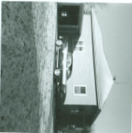
Marlene’s advice about marriage is to always communicate; make sure that you are always in agreement; spend time together and enjoy your family and go to the church of your choice.
In 1973, they bought a farm for about six hundred dollars an acre. Their first car was a 1955 Ford. Marlene and Harlyn Stubbe have four children: Doug born September 7, 1960; Marvella born November 20, 1962; Angela born April 20, 1967; and Hedy born November 30, 1971. A humorous discipline that they had to do when they were kids, (this was mostly Doug and Marvella), was to move bricks from one barn to the other and then back again. They also had to do this with snow. She wishes some of them weren’t so naughty and didn’t have to do this discipline.
Marlene and Harlyn’s first house and car
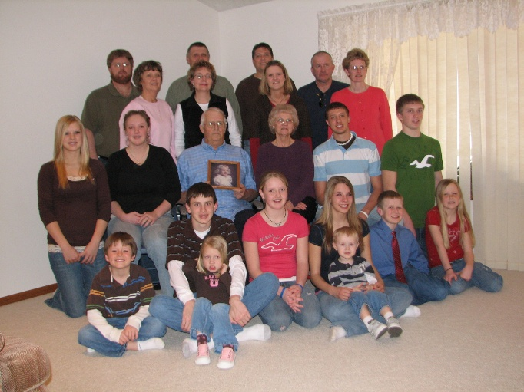
Memories about her family include the many sporting events and several vacations to the Black Hills. She remembered when Doug went on a trip to North Carolina for the Division II College Nationals (NAIA). She also remembers the state volleyball tournaments and when Marvella went to state golf and when Doug went to the All-State Choir. She also remembers all the times her other daughter Hedy went to state softball and one year to state basketball. She is most proud of her children because they all went to college.
Marlene and with Hedy, who is in her basketball uniform
Marlene now has seventeen grandchildren and one great grandchild. She enjoys watching them grow up and mature. She has enjoyed babysitting them and going to their activities and afterward when they tell her thanks for coming. She also enjoys all the hugs and kisses. However, she wishes she could teach them to play piano or organ, although she is happy that they all sing or play an instrument.
Doug at the Division II College Nationals
Harlyn and Marlene’s family as of 2008
Marlene has enjoyed playing the organ and piano for most of her life. She is proud of herself that she has been playing it since she was thirteen. She will continue to play it as long as she can.
Marlene recalls that the best day of her life was when she got married. She also liked it when her children, grandchildren, and great-grandchild were born. On the other hand, the worst days of her life were when her husband, her young sister, and her young grandchild, Kimberly, died. The thing that helped her through these times was her faith. She says that it helped her get through the deaths of some very young family members: a sister at a year and a half that died from a farming accident; A granddaughter at two and a half that had a brain tumor; her father who died at forty-seven; a mother-in-law at fifty-five; and also her husband who perished because of lung cancer at seventy-two years of age.
Marlene playing organ at church
Marlene now lives in the house that Harlyn and she built. Relationships with her grandchildren, friends and families are precious to her. Lunches with friends and families continue to add to memories to a life well lived. Being able to cheer her grandchildren on events or just watching them perform warm her heart.
Music is a passion that is evident in Marlene’s life. Playing the piano and organ at church not only bring joy to Marlene, but also echoes the joy the music brings to the heart.
Marlene’s husband Harlyn
Marlene’s sister Luella
Marlene’s granddaughter Kimberly
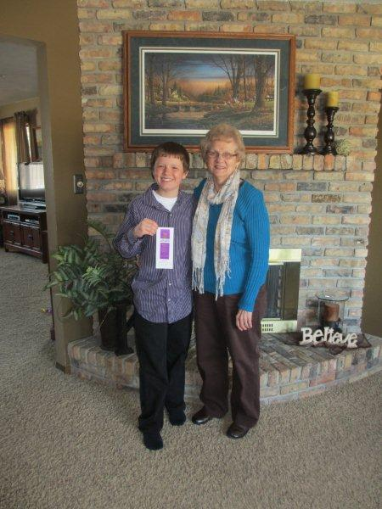
Dylan Kruger
Spring ‘14

